**Practical No. 6**

1. **Design a program for accepting decimal number**

**divisible by 2.**

1. **Decimal**

**String Accepted**

**Code:**

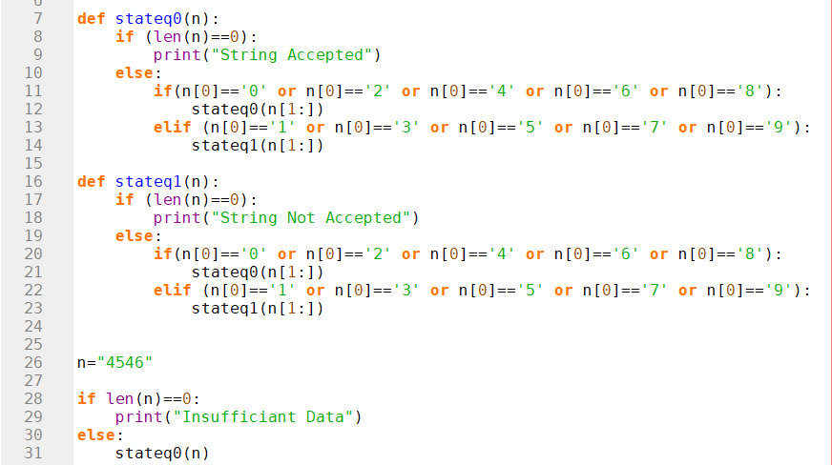

**Output:**

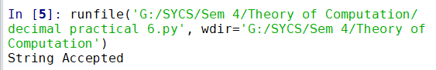

**String Not Accepted**

**Code:**

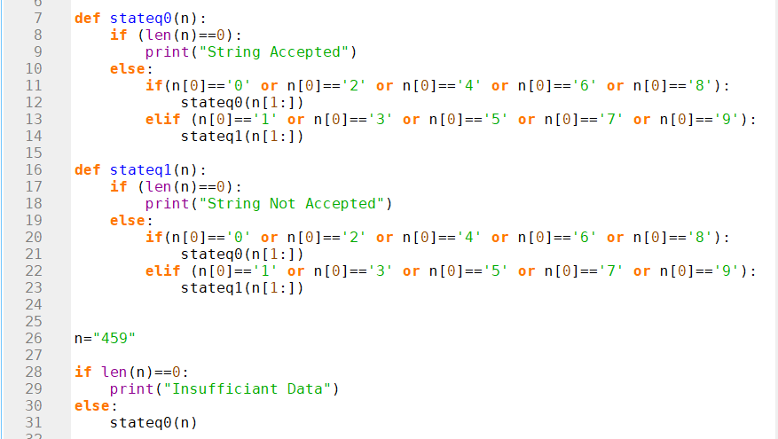

**Output:**

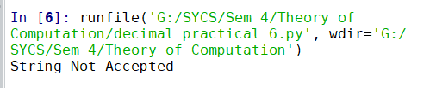

**Insufficient Data**

**Code:**

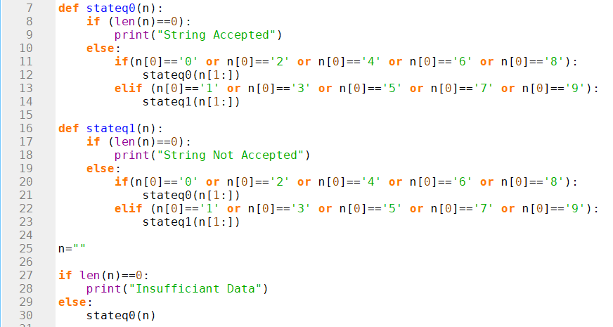

**Output:**

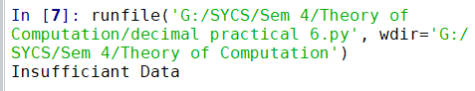

1. **Binary**

**String Accepted**

**Code:**

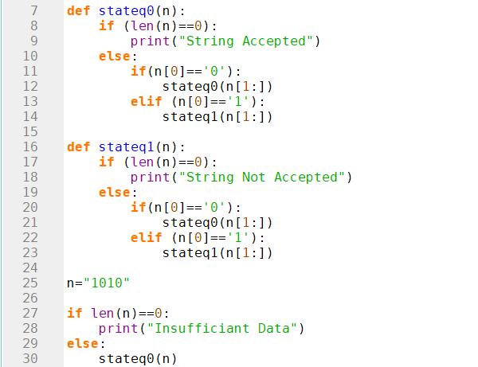

**Output:**

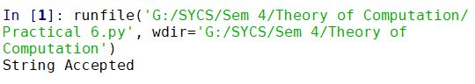

**String Not Accepted**

**Code:**

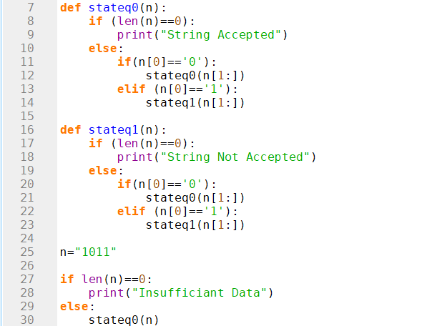

**Output:**

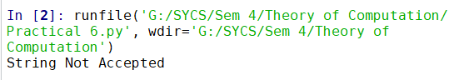

**Insufficiant Data**

**Code:**

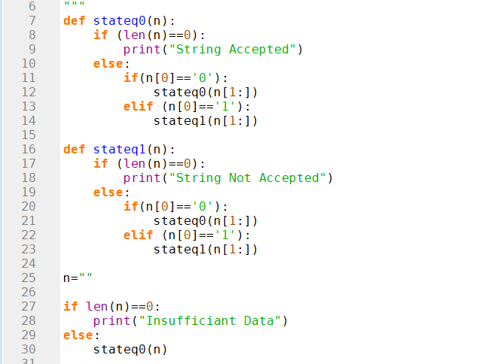

**Output:**

